Name: _________________________________________________ Date: _______________________

Address: ____________________________City:___________________ State:_____ Zip:_________

Home Phone (____)_______________Cell (____)_______________ Work (____)________________

We use text messages for appointment reminders. Who is your cell phone company? ___________

Email Address: _________________________________________________Male_____Female_____

Social Security #________________________________Birth Date: ________________ Age_______

Occupation: _____________________ Employer Name and Address__________________________

Single___Married___Spouse Name________________Emergency Contact ___________________________

How did you hear about our office? Internet, Social Media, Event, Fam/friend: ___________________­­­­

**NEW PATIENT INTAKE**

YOUR HEALTH SUMMARY

What is your chief complaint?__________________________________________________________

Have you seen a Chiropractor before? ______ If yes, when?_________________________________

Check all symptoms you have ever had even if they do not seem related to your current problem.

___Headaches ___Pins and Needles in legs ___Neck Pain ___Dizziness

___Pins and needles in arms ___Back Pain ___Loss of balance ___Fatigue

___Ringing in ears ___Numbness in fingers ___Numbness in toes ___Cold Feet

___Depression ___Tension ___Menstrual irregularity ___Cold Hands

___Sleeping problems ___Neck Stiffness ___Heartburn ___Vertigo

___Migraines ___Problem Urinating ___TMJD ___Shoulder Pain

**If you are in pain, please mark the exact location of your pain on the diagram below.**

Please list any medications you are taking: _______________________________________________

____________________________________________________________________________________

**If this is due to an injury or auto accident, what is the date of injury or accident?_______________**

Has this problem been getting better, worse, or staying the same?____________________________

**What activities make your condition worse? ______________________________________________**

**Any surgeries or hospitalizations?______________________________________________________**

**Injuries or illnesses that you have had that are not listed above:_____________________________**

**Do you have health insurance? □ Yes □ No Or a HSA account? □ Yes □ No**

**If so, please provide the front desk with your card so we can verify your benefits with our office.**

## COMPLETE THESE DIAGRAMS

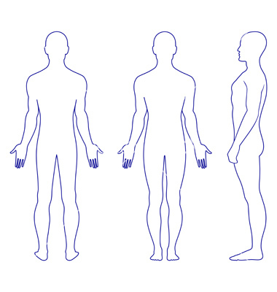

Back

Front

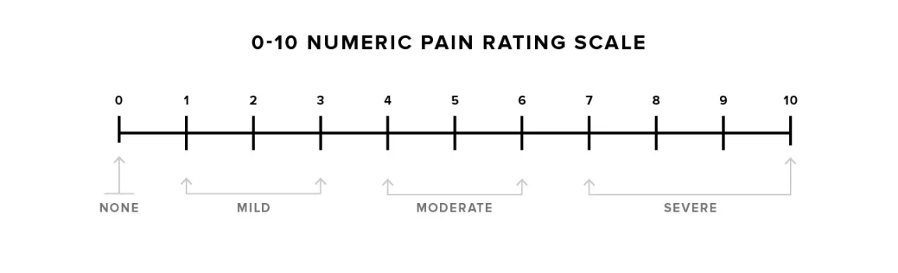**Circle pain level 0-10:**

**Female ONLY: Are you currently pregnant? Yes / No If yes, due date:____________________**

**Have you received your COVID-19 vaccination? Yes / No Date:_____________________________**

**EXERCISE. WORK ACTIVITY HABITS** (Circle One)  **Have you ever smoked?** Yes No **Do you smoke?** Yes No

___ None ___ Sitting ___ Smoking Packs/Day _____________________

___ Moderate ___ Standing ___ Alcohol Drinks/Wk _____________________

___ Daily ___ Light Labor ___ Coffee/Caffeine Drinks Cups/Day ______________________

___ Heavy ___ Heavy Labor ___ High Stress Level Reason_____________________________________

**Insurance Information**

Do you have insurance? YES____ NO ____

**Patients must bring a copy of their insurance information card to our office to bill insurance**

(The person who owns the policy)

Policy Holder’s Name _____________________________­­__________ Policy Holder’s DOB _____________

Insurance Companies Name __________________________________ Policy Holder’s SSN ________________

**Assignment & Release Statement (Insurance)**

I, the undersigned certify that I (or my dependent) have insurance coverage with ________________________________________ and assign directly to Dr. __________________________________ all insurance benefits, if any, otherwise payable to me for services rendered. I understand that I am financially responsible for all charges whether or not paid by insurance. I hereby authorize the doctor to release all information necessary to secure the payment of benefits. I authorize the use of this signature on all insurance submissions. I give authorization to **Highland Family Chiropractic, P.C.** for my treatment.

_____________________________________________ _____________________

Policy Holders Signature Date

__________________________________________________________________________________________

Dependents Names

**Cancelation Policy**

Here at Highland Family Chiropractic, we take pride in being able to offer services to established and new patients within a 24 hour notice of their request of need. In order for us to continue to accomplish this level of care we have implemented a cancellation policy that will provide established patients ease of scheduling and new patients sooner available times to start their care process. The policy is outlined below to help set our expectations in the office during your care process and beyond.

Canceling treatment visits must be done **24 hours prior to your scheduled appointment.** In the office we have text reminders that go out 24 hours prior to your visit. Cancellation can happen via text or by calling our office at 406-782-2557 (preferred method). If this is not done within the 24-hour time frame you will be billed **$30** or 50% of the cost of the visit.

If our staff members are required to call to confirm you have missed your appointment **AND** it needs to be rescheduled, we will bill you for the entirety of the unattended visit **($60).**

That being said, we understand that life happens in unpredictable ways. As an office we will take cancellations, due to an emergency, at our discretion.

By signing this document, you agree to the terms of this policy.

Name (print)_____________________________Signature___________________________Date___________

**Financial Policy**

I understand that I am financially responsible for this account and any charges and/or insurance non coverages that it may acquire during the duration of my treatment time in this office. If I should I default on payment of my account and collection agency services are required, all costs of collections up to 40% of the balance, including attorney/court costs will be added to the balance of my account.

Signature___________________________________________________ Date: ___________

**PATIENT COMPLIANCE ASSURANCE NOTIFICATION**

The Department of Health and Human Services has established a “Privacy Rule” to help ensure that personal health care information is protected for privacy. The Privacy Rule was also created in order to provide a standard for certain health care providers to obtain their patients’ consent for use and disclosure of health information about the patient to carry out treatment, payment, or health care operations.

As our patient, we want you to know that we respect the privacy of your personal medical records and will do all we can to secure and protect your privacy. We strive to always take reasonable precautions to protect your privacy. When it is appropriate and necessary, we provide the minimum necessary information about treatment, payment, or health care operations in order to provide health care that is in your best interest.

We also want you to know that, per our written policy, we support your full access to your personal medical records. We may have indirect treatment relationships with you (such as laboratories that only interact with physicians and not patients), and may have to disclose personal health information for the purpose of treatment, payment, or health care operations. These entities are most often not required to obtain patient consent.

You may refuse to consent to the use or disclosure of your personal health information, but this must be in writing. Under this law, we have the right to refuse to treat you should you refuse to disclose your Protected Health Information (PHI). If you choose to give consent in this document, at some future time, you may request or refuse all or part of your PHI. You may not revoke actions that have already been taken which relied on this or a previously signed consent.

If you have any objections to this form, please ask to speak with our HIPPA Compliance Officer. You have the right to review our privacy notice, to request restrictions, and to revoke consent in writing after you have reviewed our privacy notice.

Patient Name ________________________________________________ DOB ___________

Patient Signature _____________________________________________ Date ___________

**INFORMED CONSENT FOR CHIROPRACTIC CARE**

When a patient seeks chiropractic health care and we accept a patient for such care, it is essential for both to be working for the same objective. It is important that each patient understand both the objective and the method that will be used to attain it. This will prevent any confusion or disappointment. You have the right, as a patient, to be informed about the condition of your health and the recommended care and treatment to be provided so that you may make the decision whether or not to undergo chiropractic care after being advised of the known benefits, risks, and alternatives.

Chiropractic is a science and art which concerns itself with the relationship between structure (primarily the spine) and function (primarily the nervous system) as that relationship may affect the restoration and preservation of health. Health is a state of optimal physical, mental and social well-being, not merely the absence of disease or infirmity. One disturbance to the nervous system is called a vertebral subluxation. This occurs when one or more of the 24 vertebrae in the spinal column become misaligned and/or do not move properly. This causes altercation of nerve function and interference to the nervous system. This may result in pain and dysfunction or may be entirely asymptomatic.

Subluxations are corrected and/or reduced by an adjustment. An adjustment is the specific application of forces to correct and/or reduce vertebral subluxation. Our chiropractic method of correction is by specific adjustments of the spine. Adjustments are usually done by hand but may be performed by handheld instruments. In addition, ancillary procedures such as physiotherapy and/or rehabilitative procedures may be included.

Adjustments commonly referred to as spinal manipulations can occur in both the spine and/or extremities. The spine/extremity can take time to properly hold the adjustments based on the environmental factors that are applied to the body by each patient. Complications that can occur from chiropractic care range from but are not limited to: fractures, dislocations, muscle strains, costovertebral separations, disc herniation, stroke, and cervical myelopathy. Some patients may feel pain and stiffness for a few days after their adjustment. We will make every reasonable effort at our office to ensure that you get the best results with the lowest amount of risk by doing detailed evaluations to screen for any contraindications for care. It is your responsibility as a patient to inform the doctors about any kind of pre-existing conditions prior to starting care to minimize any side effects from any kind of care at our office.

By signing this document, you are authorizing *Highland Family Chiropractic, P.C.* and its staff to perform the following treatments, as seen fit by your chiropractor.

Physical exam

X-rays

Consultation

Cryotherapy

Chiropractic adjustments

Soft tissue techniques

Tractions therapy

Interferential therapy

Rehab training

Laser therapy

Heat therapy

Ultrasound therapy

Massage therapy

There are also dangers to not having spinal issues taken care of. If untreated for prolonged periods of time, patients will develop adhesions and therefore limit mobility. This will complicate treatment and prolong the recovery time. Sticking to the care plan, given to you by your chiropractor, is necessary to not only ensure you are recovering but to make sure you can prevent further injury from happening,

If during the course of care, we encounter non-chiropractic or unusual findings, we will advise you of those findings and recommend that you seek the services of another health care provider. All questions regarding the doctor’s objective pertaining to my care in this office have been answered to my complete satisfaction. The benefits, risks and alternatives of chiropractic care have been explained to me to my satisfaction.

I have read and fully understand the above statements and therefore accept chiropractic care on this basis.

_______________________________________ ____________________________________ __________________  
 Print Name Signature Date

**Consent to evaluate and adjust a minor child:**

I, ___________________________, being the parent or legal guardian of _________________________ have read and fully understand the above Informed Consent and hereby grant permission for my child to receive chiropractic care.

______________________________ ______________

Guardian Signature Date